|  |  |  |  |  |
| --- | --- | --- | --- | --- |
| **National University of Computer and Emerging Sciences, Lahore Campus** | | | | |
| C:\Users\saif\AppData\Local\Microsoft\Windows\Temporary Internet Files\Content.Word\final design.jpg | **Course Name:** | **Web Programming** | **Course Code:** | **CS-406** |
| **Program:** | **BS(Computer Science)** | **Semester:** | **Fall 2016** |
| **Duration:** | **180 Minutes** | **Total Marks:** | **100** |
| **Paper Date:** | **19-May-17** | **Weight** | **40%** |
| **Section:** | **ALL** | **Page(s):** | **2** |
| **Exam Type:** | **Final** |  |  |
| **Student : Name:_____________________________ Roll No.________________ Section:_______** | | | | |
| **Instruction/Notes:** | 1. Please answer all the questions (including multiple choice) on the answer book provided. | | | |

1-Which of the following component Manages lifecycles?

a-Web Server.

b-Container (Correct)

c-Servlet

Marks 2

2- Which of the following component has a reference to the response object?

a-Web Server.

b-Container (Correct)

c-Servlet (Correct)

Marks 2

3-Given req is a HttpServletRequest, which gets a binary input stream *(select all, which are correct)*:

a-BinaryInputStream s = req.getInputStream();

b- ServletInputStream s = req.getInputStream(); (Correct)

c- BinaryInputStream s = req.getBinaryStream();

d- ServletInputStream s = req.getBinaryStream();

Marks 2

4-*You can override the init() method in a servlet.*

*a- True (correct)*

*b-False*

Marks 2

5- If an HTML form does not explicitly say "method=POST", the request is still sent as a POST.

a-True

b-False (Correct)

Marks 2

6- You have been given a project to create a Hospital Management System. You need to manage the following in the web application:

* Patient information
* Doctors information
* Diagnosis
* Prescriptions
* Appointments.

The web application should be able to manage patient information. The doctor should be able to enter diagnosis and prescriptions in the web application.

* Draw a high level architecture diagram of how you would implement such a system.
* Draw a class diagram of related classes needed for this project.
* Briefly describe each component of your proposed architecture.

Marks 30

ANS:

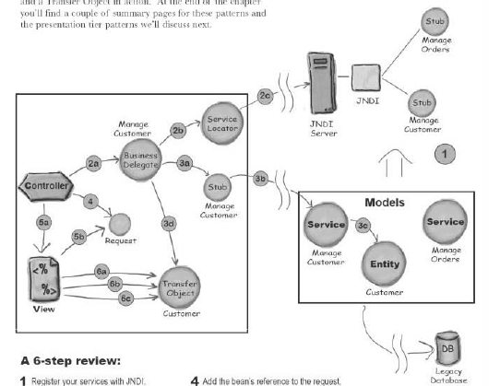

7- Write a Java Script functions which would validate the following. Write a seperate function for each of the following:

* id card number [id card should be of the following format: 111111-111111-1]
* email [email be should be of following format: email@domain.com]
* Name [Name should alphabets only]

Marks 20

ANS:

function myFunc() {

var patt = new RegExp("\d{3}[\-]\d{2}[\-]\d{4}");

var x = document.getElementById("ssn");

var res = patt.test(x.value);

if(!res){

x.value = x.value

.match(/\d*/g).join('')

.match(/(\d{0,3})(\d{0,2})(\d{0,4})/).slice(1).join('-')

.replace(/-*$/g, '');

}

}

1. **function** ValidateEmail(inputText)
2. {
3. **var** mailformat = /^\w+([\.-]?\w+)*@\w+([\.-]?\w+)*(\.\w{2,3})+$/;
4. **if**(inputText.value.match(mailformat))
5. {
6. document.form1.text1.focus();
7. **return** **true**;
8. }
9. **else**
10. {
11. alert("You have entered an invalid email address!");
12. document.form1.text1.focus();
13. **return** **false**;
14. }
15. }
16. **function** allLetter(inputtxt)
17. {
18. **var** letters = /^[A-Za-z]+$/;
19. **if**(inputtxt.value.match(letters))
20. {
21. **return** **true**;
22. }
23. **else**
24. {
25. alert("message");
26. **return** **false**;
27. }
28. }

8- What is Ajax? What are the benefits of Ajax? Describe the states an Ajax object has and what are they used for.

Marks 20

ANS:

* AJAX = Asynchronous JavaScript and XML
* AJAX is a technique for creating fast and dynamic web pages.
* AJAX allows web pages to be updated asynchronously by exchanging small amounts of data with the server behind the scenes. This means that it is possible to update parts of a web page, without reloading the whole page.

Classic web pages, (which do not use AJAX) must reload the entire page if the content should change

Ajax can do the following:

* Update a web page without reloading the page
* Request data from a server - after the page has loaded
* Receive data from a server - after the page has loaded
* Send data to a server - in the background

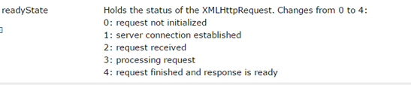

9-What are the different ways to parse XML. Briefly describe how DOM parsing works.

Marks 10

ANS:

* **Dom Parser** - Parses the document by loading the complete contents of the document and creating its complete hierarchical tree in memory.
* **SAX Parser** - Parses the document on event based triggers. Does not load the complete document into the memory.
* **XPath Parser** - Parses the XML based on expression and is used extensively in conjunction with XSLT.

**HOW DOM Parsers work:**

* **Import XML-related packages**

import org.w3c.dom.*; import javax.xml.parsers.*; import java.io.*;

* **Create a DocumentBuilder**

DocumentBuilderFactory factory = DocumentBuilderFactory.newInstance(); DocumentBuilder builder = factory.newDocumentBuilder();

* **Create a Document from a file or stream**
* StringBuilder xmlStringBuilder = new StringBuilder(); xmlStringBuilder.append("<?xml version="1.0"?> <class> </class>");
* ByteArrayInputStream input = new ByteArrayInputStream( xmlStringBuilder.toString().getBytes("UTF-8")); Document doc = builder.parse(input);
* **Extract the root element**
* Element root = doc.getDocumentElement();
* **Examine attributes**
* //returns specific attribute getAttribute("attributeName"); //returns a Map (table) of names/values getAttributes();
* **Examine sub-elements**
* //returns a list of subelements of specified name getElementsByTagName("subelementName"); //returns a list of all child nodes getChildNodes();

10- Give in detail the steps of the communication that occurs for Authentication, between a browser and a container when BASIC security is applied.

Marks 10

